**GOVERNMENT POLYTECHNIC NAGPUR**

(AN AUTONOMOUS INSTITUTE OF NAGPUR)



**DEPARTMENT OF ELECTRONICS AND TELECOMMUNICATION**

**INTERNSHIP REPORT**

**SESSION 2021-2022**

**On-Campus Internship**

**Conducted by**

Department Of Electronics and Telecommunication at

Government Polytechnic Nagpur

**GOVERNMENT POLYTECHNIC NAGPUR**

(AN AUTONOMOUS INSTITUTE OF NAGPUR)



**DEPARTMENT OF ELECTRONICS AND TELECOMMUNICATION**

***CERTIFICATE***

This certifies that **Yugal K. Nasare**, student of final year in Electronics & Telecommunication Engineering has submitted their industrial training report

**On-Campus Internship**

During academic session 2020-2021 as a part of industrial training work described by Government Polytechnic, Nagpur for partial fulfillment for the Diploma in Electronics & Telecommunication Engineering in the Fifth semester.

The industrial training work is the record of students' work under my guidance and to my satisfaction.

**Prof. Sachin Kale Dr. V. H. Mankar Technical Head Head of Dept(shift 1)**

**GOVERNMENT POLYTECHNIC, NAGPUR**

**(An Autonomous Institute of Government of Maharashtra)**

**CANDIDATE'S DECLARATION**

We declare that the industrial training report is based on work Some carried out during our study under the supervision of **Shyamal Pampattiwar** & **P.H.Gedam**.

During my internship in OnCampus Internship at Government Polytechnic Nagpur and preparation of this report, I realized that it is the joint venture guidance, assistance, and cooperation. So, it would not have been completed without help received. It is a matter of great privilege to express my deep sense of gratitude towards my guide **Shyamal Pampattiwar** & **P.H.Gedam** at Government Polytechnic Nagpur. For having this guidance.

I am extremely thankful to him for constant motivation and inspiration extended throughout during internship work which has made it possible to complete the work in scheduled time. My sincere thanks to all the faculty.

**Name of the Students: Yugal k. nasare**

**Enrollment no.: 1904042**

**Signature of Student**

**Shyamal Pampattiwar P.H.Gedam**

**Guided Guided**

**ACKNOWLEDGEMENT**

I have taken efforts in the project. However, it would not have been possible without the kind and help of support and help of many individuals and organizations. I would like to extend my sincere thanks to all of them.

I am highly indebted to ***Prof* Sachin kale** for their guidance and constant supervision as well as for providing necessary information regarding the project also for their support in completing the project. I would like to express my gratitude toward my parents & members of on **Campus Internship at Government Polytechnic Nagpur**, for their kind cooperation and encouragement which helped me in the completion of this project.

I would like to give my special gratitude and thanks to industry persons for giving me such attention and time.

My thanks and appreciation also go to my colleague in developing the project and people who have willingly helped me out with their abilities.

**Presented by**

**Yugal K. Nasare**

**BYCYCLE**

**ODDOMETER**

**COMES SPEEDOMETER**

1. **Definition**

* **Odometer:**

An odometer is an instrument used for measuring the distance traveled by a vehicle. The device may be electronic, mechanical, or a combination of the two.

* **Speedometer:**

A speedometer or speed meter is that measures and displays the instantaneous speed of a vehicle.

1. It is an digital speedometer-odometer which can be installed with a bike.
2. Digital speedometers are found only in luxury cars and high-end motor bikes.
3. The circuit uses an in Arduino Uno, 16*2 lcd display, potentiometer and hall effect Sensor
4. It is better alternative to the mechanical speedometer & even beginner with min. Skill level.
5. A speedometer or speed meter is a gauge that measures and displays the instantaneous speed of a vehicle.
6. Now universally fitted to motor vehicles, they started to be available as options in the early 20th century, and as standard equipment from about 1910 onwards.
7. The speedometer and odometer are useful features in all vehicles, helping drivers to measure their pace and estimate the distances they travel. They give important information to the drivers, helping them to make decisions that can affect their travel.

**Circuit Diagram:**

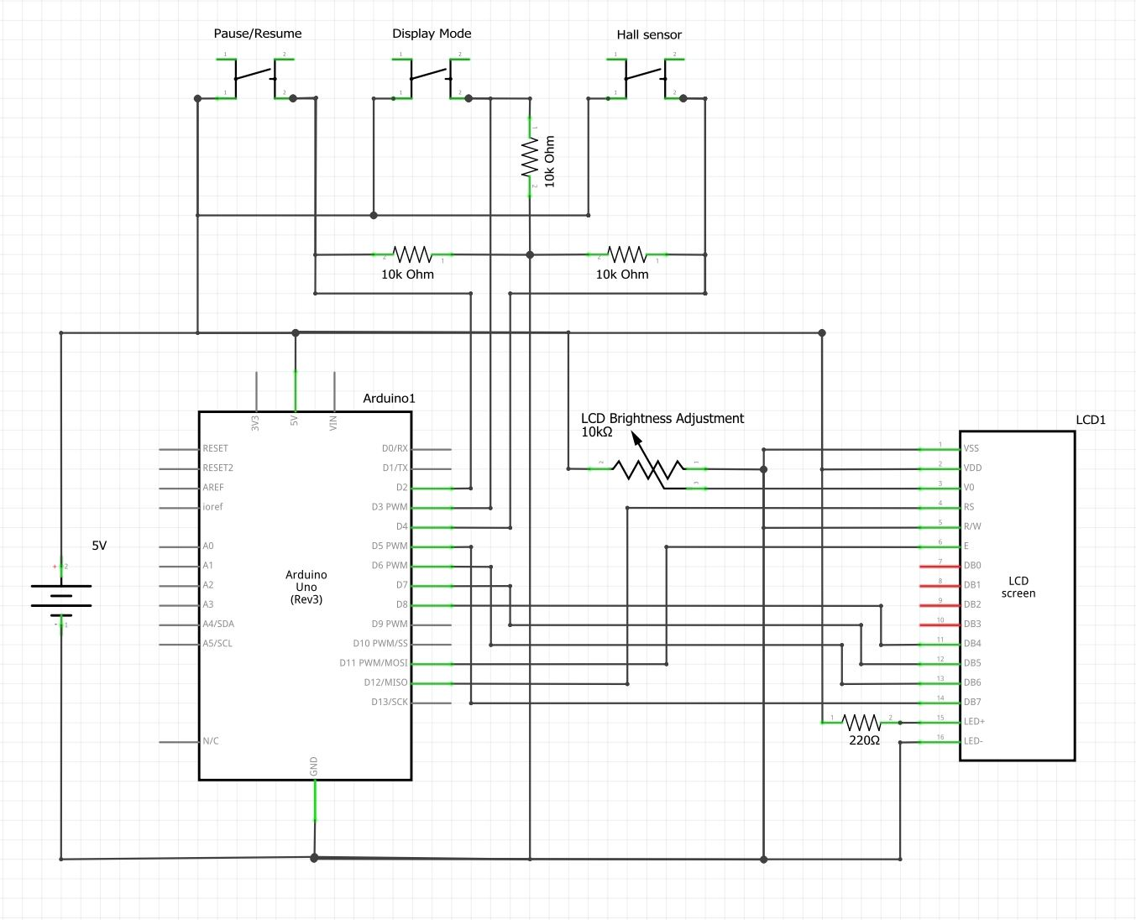

* **Circuit Discription:**
* **Arduino Uno**: Arduino is an open-source electronics platform based on easy-to-use hardware and software
* **Lcd Display**: it is use to display a Speed and distance trival, hear use a 16*2 alpha numeric lcd based on hd44780 controller.
* **Potentiometer**: A potentiometer is a three-terminal resistor with a sliding or rotating contact that forms an adjustable Resistor.
* **Hall Effect sensor**: A Hall effect sensor is a type of sensor which detects the presence and magnitude of a magnetic field.
* **Arduino Uno**

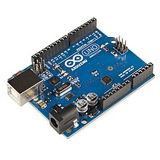

1. The Arduino Uno is an open-source microcontroller board based on the Microchip ATmega328P microcontroller and developed by Arduino.
2. The board is equipped with sets of digital and analog input/output (I/O) pins that may be interfaced to various expansion boards (shields) and other circuits.
3. The board has 14 digital I/O pins (six capable of PWM output), 6 analog I/O pins, and is programmable with the Arduino IDE (Integrated Development Environment), via a type B USB cable.
4. It can be powered by the USB cable or by an external 9-volt battery, though it accepts voltages between 7 and 20 volts.
5. It is similar to the Arduino Nano and Leonardo.
6. The hardware reference design is distributed under a Creative Commons Attribution Share-Alike 2.5 license and is available on the Arduino website. Layout and production files for some versions of the hardware are also available.
7. The word “uno” means “one” in Italian and was chosen to mark the initial release of Arduino Software.
8. The Uno board is the first in a series of USB-based Arduino boards, it and version 1.0 of the Arduino IDE were the reference versions of Arduino, which have now evolved to newer releases.
9. The ATmega328 on the board comes preprogrammed with a bootloader that allows uploading new code to it without the use of an external hardware programmer.
10. While the Uno communicates using the original STK500 protocol, it differs from all preceding boards in that it does not use the FTDI USB-to-serial driver chip.
11. Instead, it uses the Atmega16U2 (Atmega8U2 up to version R2) programmed as a USB-to-serial converter.

* **GENERAL PIN FUNCTION**

1. LED: There is a built-in LED driven by digital pin 13.
2. VIN: The input voltage to the Arduino/Genuino board when it is using an external power source.
3. 5V: This pin outputs a regulated 5V from the regulator on the board.
4. 3V3: A 3.3volt supply generated by the on-board regulator. Maximum current draw is 50 mA.
5. GND: Ground pins.
6. IOREF: This pin on the Arduino/Genuino board provides the voltage reference with which the microcontroller
7. operates.
8. IOREF: This pin on the Arduino/Genuino board provides the voltage reference with which the microcontroller
9. operates.

* **SPECIAL PIN FUNCTION:**

1. Serial / UART: pins 0 (RX) and 1 (TX). Used to receive (RX) and transmit (TX) TTL serial data.
2. External interrupts: pins 2 and 3. These pins can be configured to trigger an interrupt on a low value, a rising or
3. falling edge, or a change in value.
4. PWM (pulse-width modulation): pins 3, 5, 6, 9, 10, and 11. Can provide 8-bit PWM output with the analog Write()
5. SPI (Serial Peripheral Interface): pins 10 (SS), 11 (MOSI), 12 (MISO), and 13 (SCK). These pins support SPI
6. communication using the SPI library.
7. TWI (two-wire interface): pin SDA (A4) and pin SCL (A5). Support TWI communication using the Wire library.
8. AREF (analog reference): Reference voltage for the analog inputs

* **PROGRAMMING:**

1. The Arduino Uno can be programmed with the (Arduino Software).
2. Select “Arduino Uno from the tools>Board menu(according to the microcontroller on your board).
3. The ATmega328 on the Arduino Uno comes programmed with a bootloader
4. that allows you to upload new code to it without the use of an external hardware programmer. It communicate using the original STK500 protocol.

* **Lcd Display:**

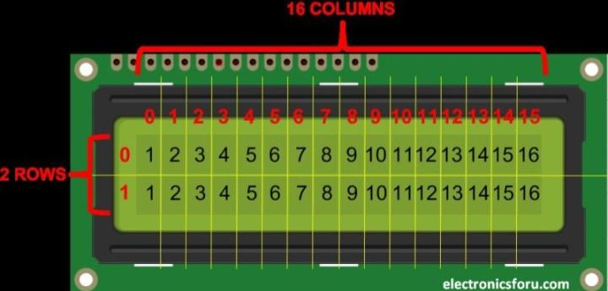

1. An LCD or liquid crystal display is a combination of two states of material ie, the solid & the liquid.
2. These displays use a liquid crystal to produce a visible image. LCDs are super thin technology display screen that are used in cell phones, TVs, portable video games, laptops, computer screen, portable video games.
3. The most common types of monochrome LCDs are called character display or alphanumeric display. Alphanumeric LCD displays are to display alphabets and numbers. The 16×2 intelligent alphanumeric dot matrix displays are capable of displaying 224 different symbols and characters.

* **Why adafruit (16×2) display is called RGB display:**
* The reason that you can mix any color you like by varying the quantities of red, green and blue light is that your eye has three types of light receptor in it (red, green and blue). Your eye and brain process the amounts of red, green and blue and convert it into a color of the spectrum.
* **Pin function and working:**

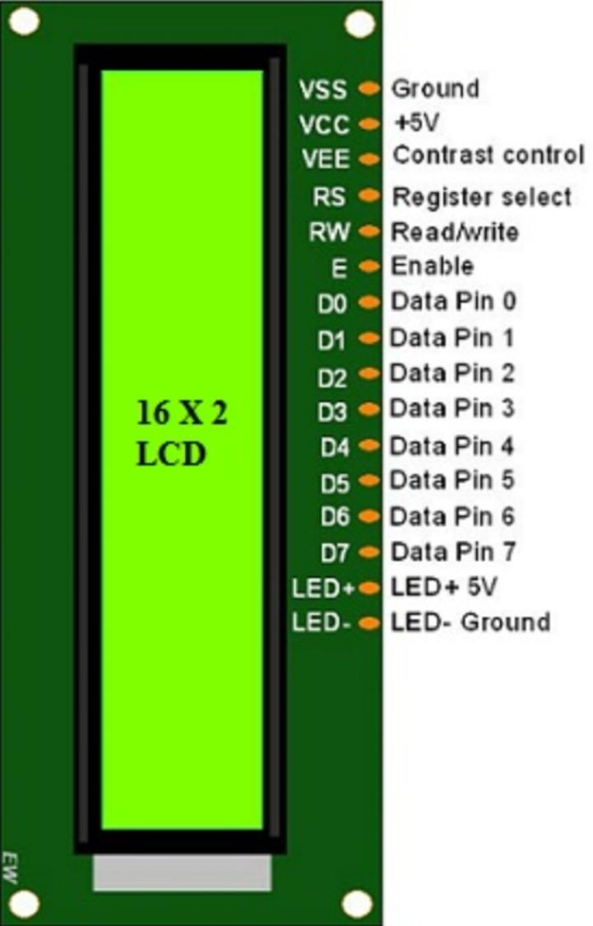

* Pin1 (Ground): This pin connects the ground terminal.
* Pin2 (+5 Volt): This pin provides a +5V supply to the LCD
* Pin3 (VE): This pin selects the contrast of the LCD.
* Pin4 (Register Select): This pin is used to connect a data pin of an MCU & gets either 1 or 0. Here, data mode = 0 and command mode =1.
* Pin5 (Read & Write): This pin is used to read/write data.
* Pin6 (Enable): This enables the pin must be high to perform the Read/Write procedure. This pin is connected to the data pin of the microcontroller to be held high constantly.
* Pin7 (Data Pin): The data pins are from 0-7 which are connected through the microcontroller for data transmission. The LCD module can also work on the 4-bit mode through working on pins 1, 2, 3 & other pins are free.
* Pin8 – Data Pin 1
* Pin9 – Data Pin 2
* Pin10 – Data Pin 3
* Pin11 – Data Pin 4
* Pin12 – Data Pin 5
* Pin13 – Data Pin 6
* Pin14 – Data Pin 7
* Pin15 (LED Positive): This is a +Ve terminal of the backlight LED of the display & it is connected to +5V to activate the LED backlight.
* Pin16 (LED Negative): This is a -Ve terminal of a backlight LED of the display & it is connected to the GND terminal to activate the LED backlight.

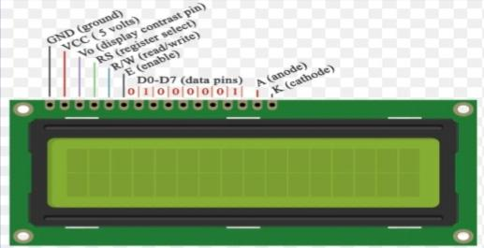

* **Hall effect sensor:**

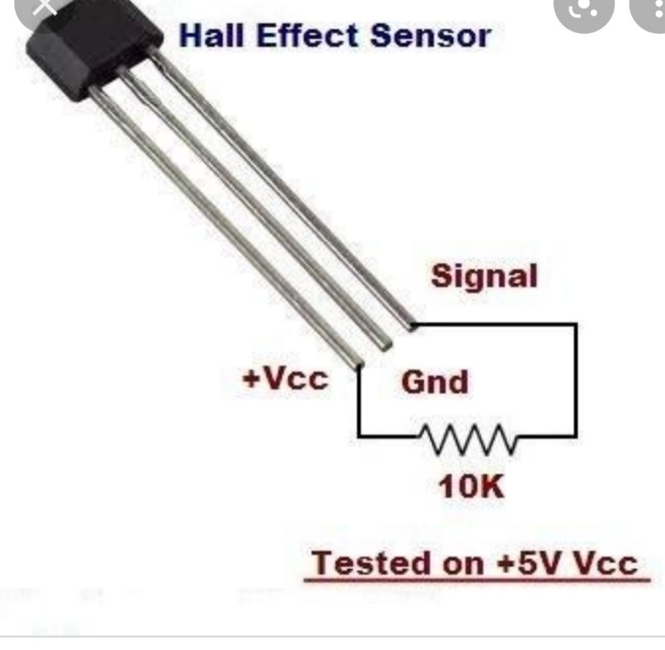

1. A Hall effect sensor (or simply Hall sensor) is a type of sensor which detects the presence and magnitude of a magnetic field using the Hall effect.
2. The output voltage of a Hall sensor is directly proportional to the strength of the field. It is named for the American physicist Edwin Hall.
3. A Hall effect sensor is an electronic device that is designed to detect the Hall effect, and convert its findings into electronic data, either to switch a circuit on and off, provide a measurement of a varying magnetic field, be processed by an embedded computer or displayed on an interface.
4. Whenever we place a current carrying conductor in a magnetic field, there is a deflection of the charge carriers due influence of magnetic field in the conductor body
5. We call this typical phenomenon as Hall effect. ... The electric current means a flow of charge.
6. Hall sensors are also used in [brushless DC motors](https://en.m.wikipedia.org/wiki/Brushless_DC_electric_motor) to sense the position of the rotor and to switch the transistors in the right sequence.
7. Hall sensors are commonly used to time the speed of wheels and shafts, such as for internal combustion engine ignition timing, tachometers and anti-lock braking systems.
8. Hall effect sensors are non-contact, which means that they do not have to come in contact with a physical element.
9. They can produce either a digital (on and off) or analog (continuous) signal depending on their design and intended function.
10. Hall Effect sensors are used for detecting and measuring proximity, position, and speed, through their ability to sense magnetic fields. As non-contact sensors, they are useful for measuring AC and DC current.
11. The applications of Hall-effect sensors are as follows  
    When combined with threshold detection they act as a switch.  
    These are used in ultra-high-reliability applications such as keyboards.

* **Potentiometer:**

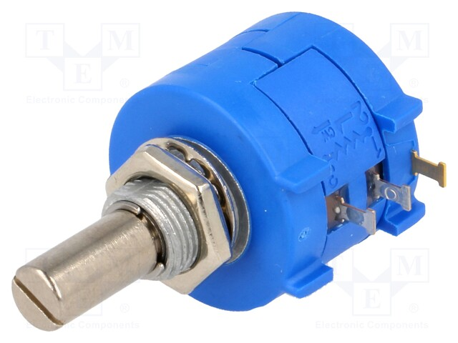

1. A potentiometer is a **three-terminal resistor with a sliding or rotating contact** that forms an adjustable voltage divider. ... Potentiometers are commonly used to control electrical devices such as volume controls on audio equipment.
2. A **potentiometer** is a three-[terminal](https://en.wikipedia.org/wiki/Terminal_(electronics)) [resistor](https://en.wikipedia.org/wiki/Resistor) with a sliding or rotating contact that forms an adjustable [voltage divider](https://en.wikipedia.org/wiki/Voltage_divider)
3. If only two terminals are used, one end and the wiper, it acts as a **variable resistor** or **rheostat**.
4. The measuring instrument called a [potentiometer](https://en.wikipedia.org/wiki/Potentiometer_(measuring_instrument)) is essentially a [voltage divider](https://en.wikipedia.org/wiki/Voltage_divider) used for measuring [electric potential](https://en.wikipedia.org/wiki/Electric_potential) (voltage); the component is an implementation of the same principle, hence its name.
5. Potentiometers operated by a mechanism can be used as position [transducers](https://en.wikipedia.org/wiki/Transducer), for example, in a [joystick](https://en.wikipedia.org/wiki/Joystick). Potentiometers are rarely used to directly control significant power (more than a [watt](https://en.wikipedia.org/wiki/Watt)), since the power dissipated in the potentiometer would be comparable to the power in the controlled load.

* Construction

Potentiometers consist of a [resistive element](https://en.wikipedia.org/wiki/Electrical_resistivity_and_conductivity), a sliding contact (wiper) that moves along the element, making good electrical contact with one part of it, electrical terminals at each end of the element, a mechanism that moves the wiper from one end to the other, and a housing containing the element and wiper.

* **Push button :**

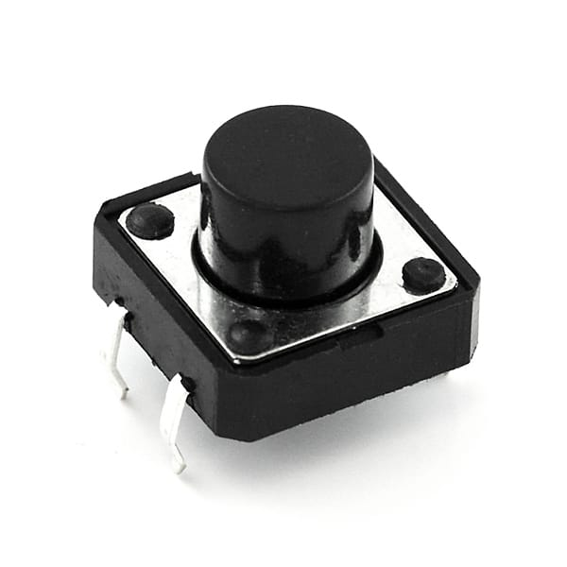

1. A push-button (also spelled pushbutton) or simply button is a simple [switch](https://en.wikipedia.org/wiki/Electrical_switch) mechanism to control some aspect of a [machine](https://en.wikipedia.org/wiki/Machine) or a [process](https://en.wikipedia.org/wiki/Process_(engineering)).
2. Buttons are typically made out of hard material, usually [plastic](https://en.wikipedia.org/wiki/Plastic) or [metal](https://en.wikipedia.org/wiki/Metal).[[1]](https://en.wikipedia.org/wiki/Push-button#cite_note-1) The surface is usually flat or shaped to accommodate the human finger or hand, so as to be easily depressed or pushed.
3. Buttons are most often [biased switches](https://en.wikipedia.org/wiki/Switch#Biased_switches), although many un-biased buttons (due to their physical nature) still require a [spring](https://en.wikipedia.org/wiki/Spring_(device)) to return to their un-pushed state.
4. Terms for the "pushing" of a button include pressing, depressing, mashing, slapping, hitting, and punching.

* **Specifications:**

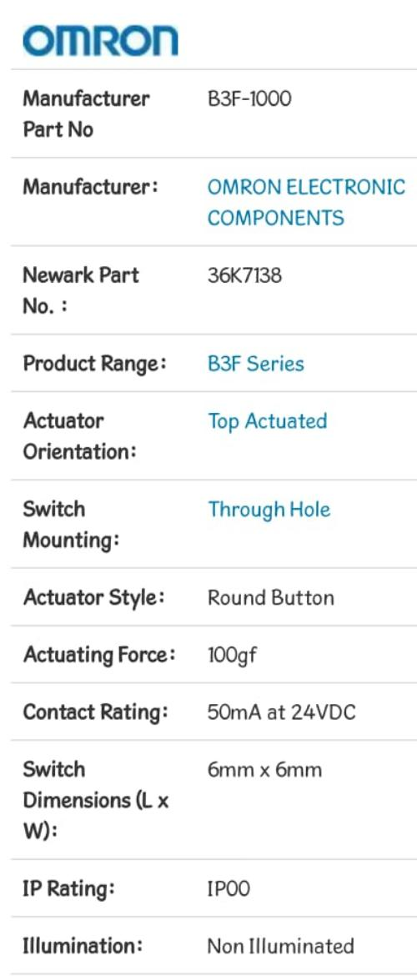

* **Resistor:**

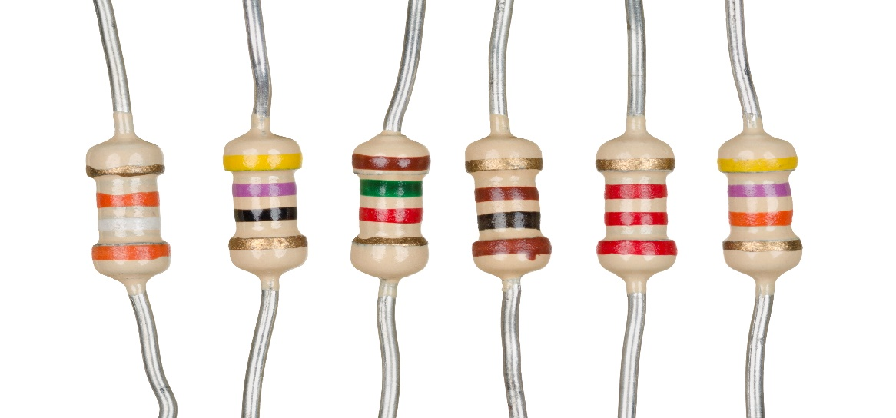

1. A **resistor** is a [passive](https://en.wikipedia.org/wiki/Passivity_(engineering)) [two-terminal](https://en.wikipedia.org/wiki/Terminal_(electronics)) [electrical component](https://en.wikipedia.org/wiki/Electronic_component) that implements [electrical resistance](https://en.wikipedia.org/wiki/Electrical_resistance) as a circuit element.
2. In electronic circuits, resistors are used to reduce current flow, adjust signal levels, to [divide voltages](https://en.wikipedia.org/wiki/Voltage_divider), [bias](https://en.wikipedia.org/wiki/Biasing) active elements, and terminate [transmission lines](https://en.wikipedia.org/wiki/Transmission_line), among other uses. High-power resistors that can dissipate many [watts](https://en.wikipedia.org/wiki/Watt) of electrical power as heat, may be used as part of motor controls, in power distribution systems, or as test loads for [generators](https://en.wikipedia.org/wiki/Electric_generator).
3. Fixed resistors have resistances that only change slightly with temperature, time or operating voltage.
4. Variable resistors can be used to adjust circuit elements (such as a volume control or a lamp dimmer), or as sensing devices for heat, light, humidity, force, or chemical activity.
5. Resistors are common elements of [electrical networks](https://en.wikipedia.org/wiki/Electrical_network) and [electronic circuits](https://en.wikipedia.org/wiki/Electronic_circuit) and are ubiquitous in [electronic equipment](https://en.wikipedia.org/wiki/Electronics).
6. Practical resistors as discrete components can be composed of various compounds and forms. Resistors are also implemented within [integrated circuits](https://en.wikipedia.org/wiki/Integrated_circuits).

* **Working:**

1. When the Arduino is initially powered on or reset, a "PRESS BUTTON TO START" message will appear on the 16 x 2 LCD screen.
2. Pressing either the Pause, Resume or Display Mode button will start the 1st lap. A "CYCLE SAFELY!" message will initially appear for a 2 second period during which recording is already ongoing.
3. The display will then show the kilometers traveled, km/hr. and average km/hr for lap/period (to the right of "A" on 2nd line, A=Average). This is updated in real-time.
4. Pressing the Display Mode button will change the “A” on 2nd line to an “M” indicating maximum km/hr traveled during the lap so far (M=Maximum).
5. Pressing the Pause/Resume button will stop recording and save the current lap data into memory.
6. The message "PAUSED!" will appear for 2 seconds and then the totals for the lap just finished will appear with the lap number shown in the upper-left-hand on display, “On the second line the distance in kilometers is shown followed by duration of lap in hours, minutes and seconds.
7. Pressing the Display Mode button when in pause mode will cycle through the different laps recorded. The first press will show the grand totals for all laps (with a “T” shown in upper-left-hand corner of the display), Depending on how many laps you recorded.
8. Pressing the Pause/Resume button again will put the device back into recording mode, recording a new lap. A “CYCLE SAFELY!” message will appear for 2 seconds first and then the real-time lap information explained previously will appear.
9. If the Pause/Resume button is pressed again while the “CYCLE SAFELY!” message appears (so during initial 2 seconds of new lap), no lap data will be recorded and the device will be put back into pause mode showing the data for the last lap traveled.
10. Only data for 99 laps/periods can be recorded. Once the 99th lap is recorded, any additional laps will be recorded into the slot for the 99th lap thus overriding the previous data stored.

* **Calculation:**
* A bicycle wheel has a radius of 35 cm. How far does Alice cycle on her bicycle if the wheel revolves 250 times ?

Answer :- The circumference of circle = 2πr

> C= 2* π* 35

> c=70 π

so,

distance = Circumference of Circul * time

= 250 * 70 π

= 17500 π

= 54977.8714 cm

= 550 m

* **Features:**

1. Digital reAd out.
2. Speed display in km/hr.
3. Distance trivel display in km.
4. Reliability Dut to use of Arduino Uno.
5. Home-breWed Speed transducer Or sensor
6. Self reset To zero after CompletOn Of 99999.9 km.
7. Easy to duild And fixed on the bike.

* **Application:**

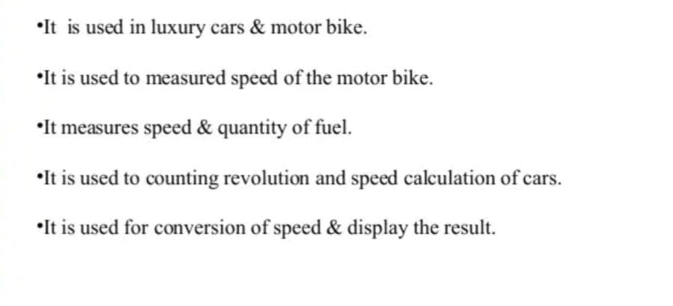

**Project View:**

